Toolkit for Organisations
You have joined another 600 arts and cultural organisations and individuals who are showing their commitment to families by signing up to the Family Arts Standards.
This toolkit is a simple guide to communicating this commitment to your family audience and offers guidance on how to use the Standards in practice to improve your family offer.
Contents
- Branding
- Social media
- Press
- Benefits from Family Arts Campaign
- Training & Resources
- Age-Friendly Standards
- Advocacy

- Branding
Families are coming to recognise the Standards logo as a badge of excellence, so we encourage you to use the branding on your marketing materials and website.
To download the assets and branding guidelines follow this link and it will start the download automatically.
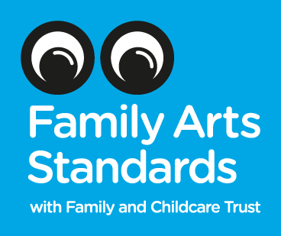
There are two logos:
For Organisations: the Standards logo, which indicates your overall family friendly offer, to be used in your brochure, on your website and in your venue (if you have one).
Recent research by the Family and Childcare Trust shows that organisations promoting that they have signed up to the Standards are more likely to see an increase in families visiting and taking part in their activities. Read more here.

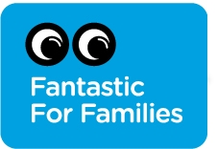
For Events: the Fantastic for Families logo, to mark individual events that are appealing to families. 8 out of 10 families said there was a need for a nationally recognised family friendly logo. The Fantastic for Families event logo is just as important as the main Standards logo as audiences are looking for reassurance that particular arts events are suitable for their family.
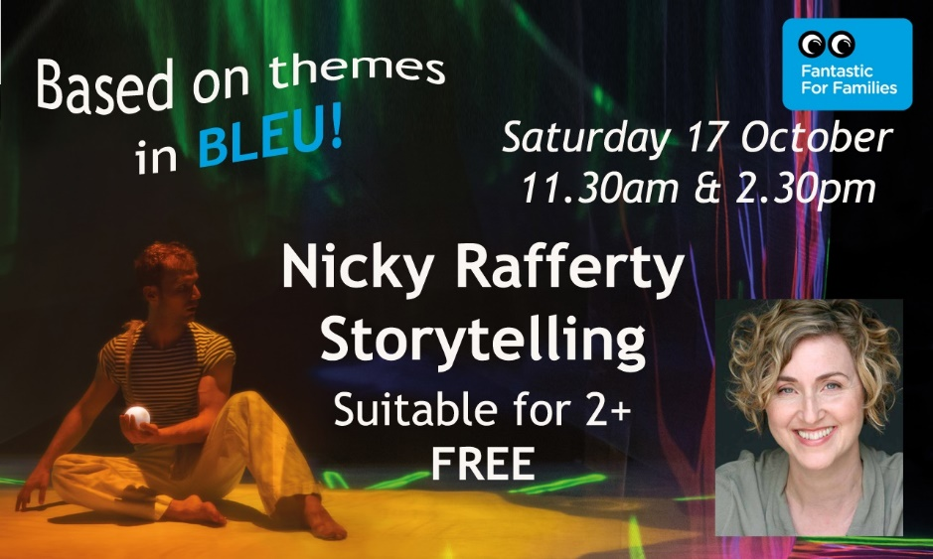
Badging an event as Fantastic for Families, as in the example above, is an easy way to communicate that the work on offer has been made with families in mind. For more guidance on communicating your offer to families see our free Content Guidance toolkit.
When using online, remember to link both logos to the audience facing Standards website: familyartsstandards.com.
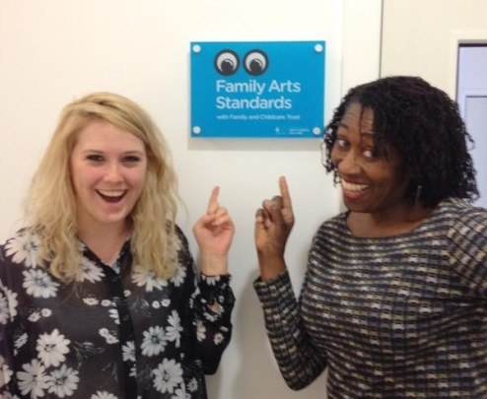
Wall Plaque
You can now order your Family Arts Standards wall plaque to show your audiences that you’ve made the commitment of signing up to the Standards. We’ve covered part of the cost to ensure that you can welcome more families into your building, or show off your family friendly status within your office. Order yours here for £40 + VAT.

- Social Media
Let your audiences know you’ve signed up to the Standards by Tweeting and posting on Facebook:
We're proud to be #FantasticforFamilies thanks to the Family Arts Standards www.familyartsstandards.com. #familyarts [Standards logo]
Tag us on Twitter @fantasticforfam and with the hashtag #fantasticforfamilies, and on Facebook and Instagram at Fantastic for Families.
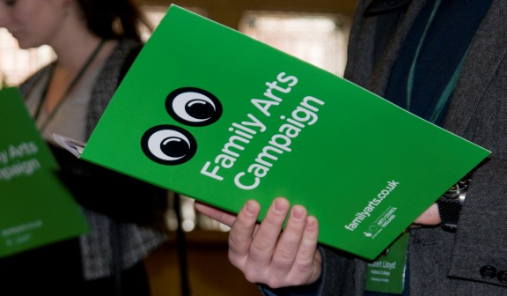
- Press
Let your local press know you’ve made this commitment to family audiences and that you meet the Standards guidelines, which were designed in consultation with families themselves. Use this press release template to let them know and attract media attention.
- Benefits from the Family Arts Campaign
Now that you’re a Family Arts Standards-holding organisation you can receive free promotion from the Campaign through:
- Your own dedicated page on fantasticforfamilies.com
- Opportunities for inclusion of your family arts events in our family e-news
- Promotion of your family arts events on our social media channels
What you need to do:
- Register on fantasticforfamilies.com and add or update your organisation details if necessary
- Let us know relevant contacts for Standards correspondence – we’ll contact you when we have free space available to boost your event listings
- Add us to your press list for family events information: contact info@fantasticforfamilies.com

- Training & Resources
The Family Arts Campaign offer a set of resources specifically designed to accompany the Standards:
- Case studies: a set of case studies from a range of organisations who have signed up to the Standards
- Event resources: When you upload listings for your family events, you'll find a number of relevant resources in your log-in area.
- Booster seat guide: guidance on the use of booster seats in order to enable younger family members to fully enjoy performances.
The full Campaign resources library can be found here and training events here.
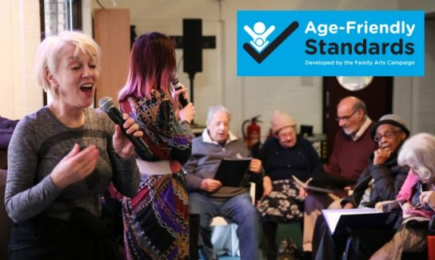
For questions about the Standards read the FAQ here.
- Age-Friendly Standards
You can also sign up to the Age-Friendly Standards, which are designed to complement the existing Family Arts Standards. The Age-Friendly Standards are a national self-assessed accreditation for cultural organisations and a recognised and trusted symbol for older audiences and family groups including older people. Organisations that sign-up to these Standards value all generations and want to provide a welcoming and positive experience for visitors, regardless of their age.
For more information and to sign up visit our Age-Friendly Standards page.
- Advocacy
The reputation and brand of the Standards grow with each organisation that signs up, whilst organisations are increasingly looking to work with venues and practitioners who share their commitment to family audiences. So how about encouraging other organisations you work with to sign up too?
- Use our advocacy email template to contact 5 organisations you work with. To avoid preaching to the converted you can see a list of organisations who have already signed up by visiting familyartsstandards.com.
- Tweet a link to our Family Arts Standards advocacy film to three of your contacts: We’re extending our welcome to families with the Family Arts Standards. Sign up for free https://vimeo.com/157280097 - or retweet ours here.
Any Questions?
Visit familyarts.co.uk/family-arts-standards
Or get in touch:
Jenny Daly, Head of Campaign: jenny@thealbany.org.uk, 020 3409 6575
Clair Donnelly, Project Manager: clair@thealbany.org.uk, 020 3198 6106
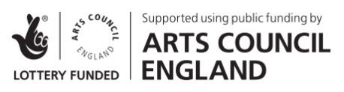
www.familyartsstandards.com

